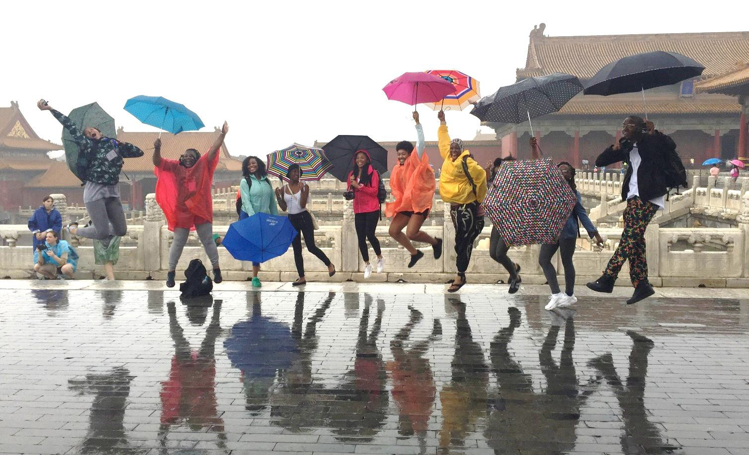

2-WEEK SPONSORED SUMMER STUDENT STUDY VISITS TO CHINA

2017 APPLICATION PACKET

Presented to:
Congresswoman Barbara Lee

California – 13th District

DEADLINE February 20, 2017

Email sbrown@peralta.edu for an application or visit the www.merritt.edu

THE CHINA-UNITED STATES EXCHANGE FOUNDATION

The China-United States Exchange Foundation (CUSEF) was established in 2008 as a non-government, non-profit entity based in Hong Kong, and is fully supported by private donations. The Foundation’s aim is to promote mutual understanding and trust through open and constructive communications and exchanges between the two peoples of the People’s Republic of China and the United States of America.

The Foundation believes understanding and trust are the cornerstones of success for the world's most important bilateral relationship. Our programs serve as a critical bridge for the two countries by facilitating open and constructive exchange among policy-makers, business leaders, academics, think tanks, cultural figures, and educators from China and the United-States.

CUSEF also has a long-term goal of engaging future leaders of the two nations. From the year of 2013 to 2016, the Foundation sponsored and/or organized more than 20 student delegations, ranging from high school students to postgraduate students, to visit China in an effort to nurture knowledge and foster a deeper understanding between Chinese and American citizens. To date, more than 300 American students have benefited from the study program.

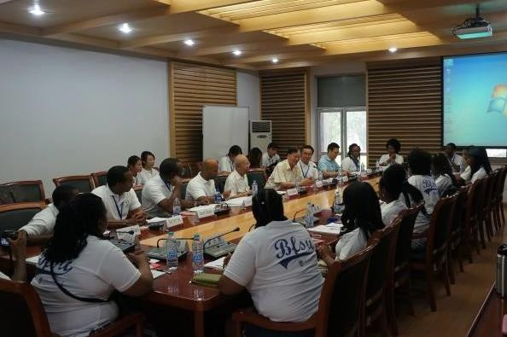
CUSEF has appointed Wilson Global Communications as the Foundation’s international liaison representative in the U.S. to coordinate the CBC student visits to China. Wilson Global Communications (Wilson Global) is an international public relations and communications consulting firm specializing in Strategic Public Relations Services between the United States and various countries in Africa, Europe, China, and Latin America. Founded in 1994 in South Africa by Julia A. Wilson and based in Washington, D.C., Wilson Global focuses customized services on building and bridging relationships between American and foreign leaders and organizations in education, business, media, and civic affairs.

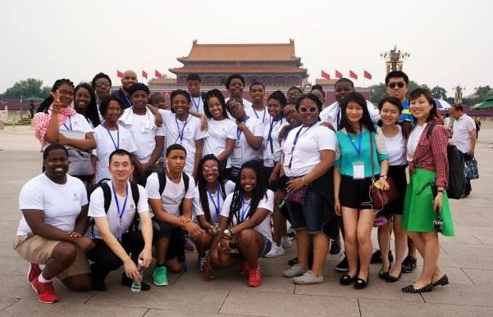

STUDENT STUDY VISITS TO CHINA
This is a two-week study delegation targeting college students from Congressional Black Caucus member districts to visit China in the summer. During the 14-day visit, in addition to the cultural visits, students are expected to learn about Chinese language, history, culture, economic development, clean energy and other important subjects by attending lectures in Chinese universities such as Beijing Language and Culture University and Beijing Foreign Studies University. CUSEF and Chinese partners cover all the necessary group expenses including accommodation, transportation, sightseeing tickets and meals, etc. within mainland China.

Since 2013, students from several CBC member districts have participated in the student study visits to China under this program, including: Rep. Barbara Lee (CA-13); Rep. Sheila Jackson Lee (TX-18), Rep. Hank Johnson (GA-04); Rep. Marcia Fudge (OH-11); Rep. G. K. Butterfield (NC-01); Rep. Gregory Meeks (NY-05); and Rep. Charles Rangel (NY-13).

Quick Facts
1. Duration and cities to visit: Normally 2 weeks, and groups visit 2 – 3 cities such as Beijing, Hangzhou, Shanghai or others. (Groups normally fly into Beijing and depart from Shanghai)
- Size of Study Group: Normal size would be 24 – 26 students with 2 chaperones
- Funding of program:
➔ CUSEF and its partners and sponsors cover all costs incurred for the program in mainland China, including accommodation, tuition, scheduled group meal and refreshment at breaks, field/site visits, local transportation, interaction with local student or family as well as touring of cultural and historic attractions.
➔ Sponsoring organization/entity of Student Study Group on behalf of CBC member covers all international travel costs outside China for all participating students, chaperones and accompanying staff, including international airfare, visa and travel insurance. Participants are advised to bring additional funds to cover personal and incidental expenses.
- Subjects Covered: CUSEF works with each group to customize the study lessons and activities.
Previous subjects include Chinese culture, basic Mandarin, economics, environmental studies, China’s history, China’s 12th 5-year plan.

SAMPLE SCHEDULE AT A GLANCE

SUNDAY
AM Participants arrive at Beijing International Airport
15:00 Check-in at the hotel 18:30 Dinner

MONDAY
09:00 Gathering at hotel lobby
09:30 Opening Ceremony
10:30 Seminar: China-U.S. Relations 12:00 Welcome Lunch
13:30 Culture Tour: The Great Wall 18:00 Welcome Dinner

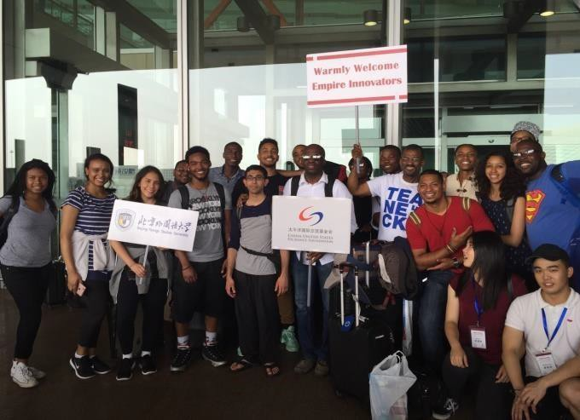

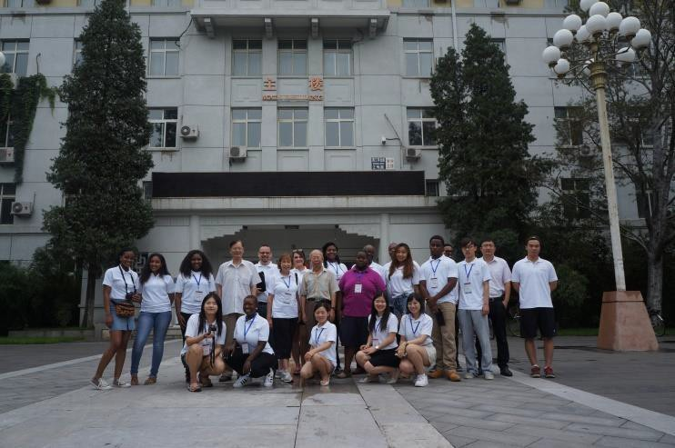
TUESDAY
08:30 Gathering at hotel lobby
09:00 Seminar: Chinese Language (1)
10:30 Seminar: Chinese Philosophy (Confucius, Laozi, and Sunzi) 12:00 Lunch
13:00 Culture Tour: Summer Palace 18:00 Dinner

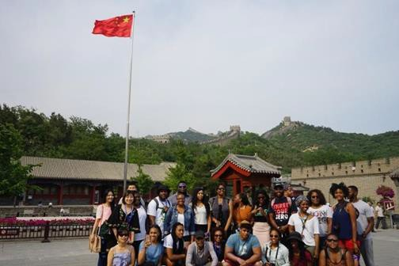
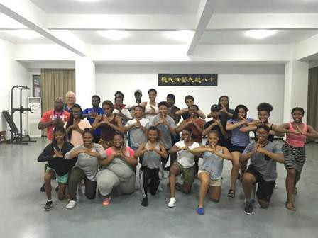

WEDNESDAY
08:30 Gathering Time at Hotel Lobby
09:00 Seminar: Political System and Economic Development in China 10:30 Culture Experience: Peking Opera
12:00 Lunch
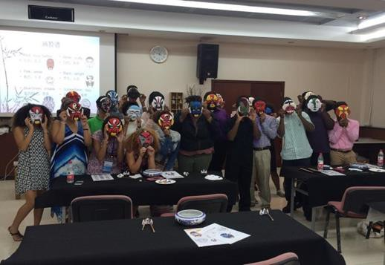
13:30 Culture Tour: Forbidden City 17:30 Dinner

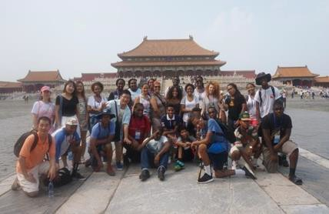

THURSDAY
08:30 Gathering Time at Hotel Lobby
09:00 Culture Experience: Dragon Dance, Tai Chi-Fan 10:30 Seminar: Education System in China
12:00 Lunch
13:30 Seminar: Chinese Astrology and Everyday Life: The Heavenly Stems and Earthly Branches 15:00 Workshop: Chinese Calligraphy & Painting
17:30 Chinese Acrobatics Show& Dinner

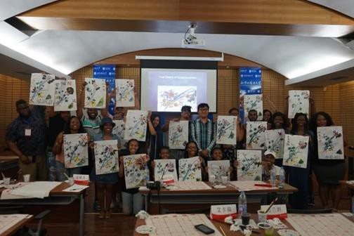
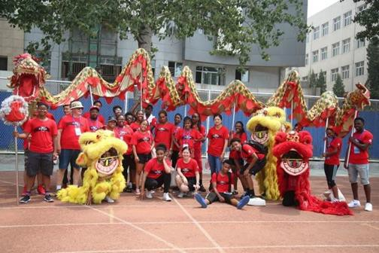

FRIDAY
08:40 Gathering Time at Hotel Lobby
09:00 Seminar: Chinese Language (2) 10:30 Seminar: Ethnic Minorities in China 12:00 Lunch
14:00 Meet Local Students 18:00 Farewell Dinner

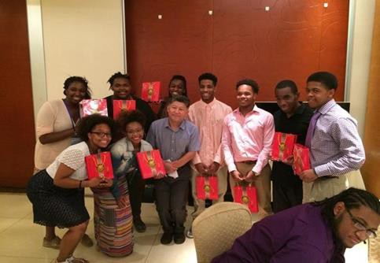
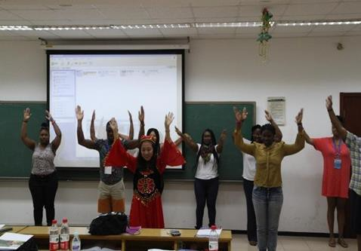

SATURDAY
06:30 Hotel Check-out
07:00 Depart Hotel for Beijing South Station
09:15 Departure for Hangzhou via G41 Bullet Express 15:44 Arrival at Hangzhou East Station
18:00 Check-in at Wanxiang Polytechnic International Exchange Centre 18:30 Welcome Dinner and Opening Ceremony

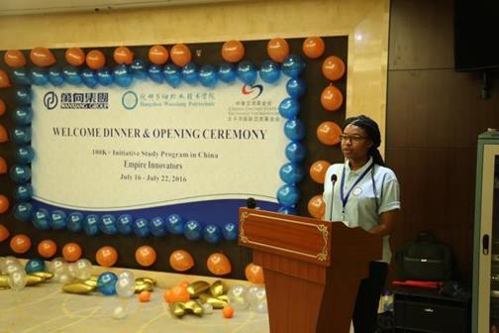

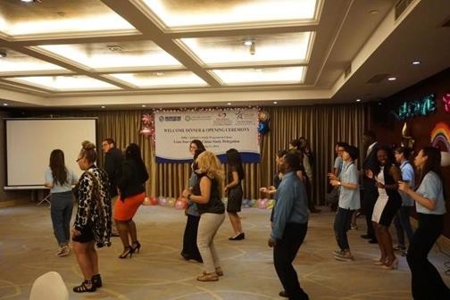
--------- More details available upon request -----------

PROGRAM DETAILS

Accommodation
    - During the 2-week visit, students will live in three hotels (4-star standard) located in Beijing, Hangzhou and Shanghai respectively.
    - Normally, two students of the same gender will share a room.
    - Towels, hair dryer, shower/bath gel, toothpaste will be provided in all hotels.

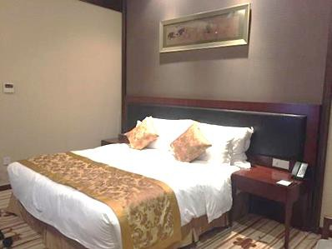
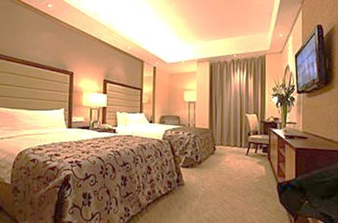

Food
    - Breakfast: Breakfast buffet will be provided in all hotels
    - Lunch: Groups normally dine at the Chinese restaurant located in/near the campus
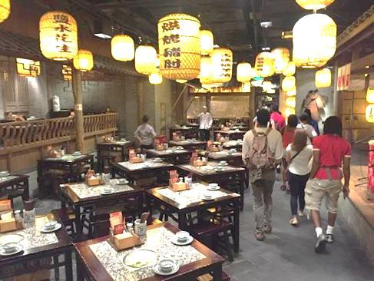
    - Dinner: Groups visit specialty restaurants in China and enjoy the Chinese/Western food

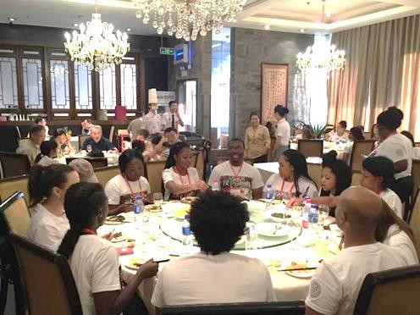

Transportation
    - Groups will travel by coach bus (with at least 39 seats) to visit all tourist destinations in Beijing, Hangzhou and Shanghai
    - To travel to Hangzhou from Beijing, groups usually take a high-speed railway (308km/hr maximum).

Clothing
    - Due to the hot summer weather in China, it is recommended that all delegates bring casual wear for sightseeing activities.
    - For the formal closing ceremony in Hangzhou, please bring a formal suit/dress for the event.

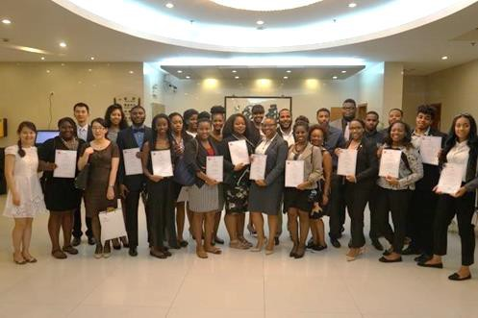
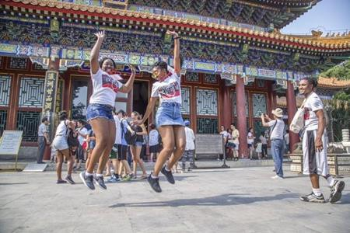

Shopping
- Students can buy traditional Chinese arts & crafts, key chains, fans, and all the other souvenirs in tourist destinations (e.g. The Great Wall in Beijing, Song Dynasty Town in
Hangzhou & Yu Garden in Shanghai).

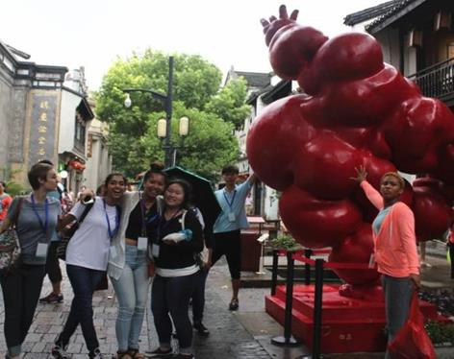
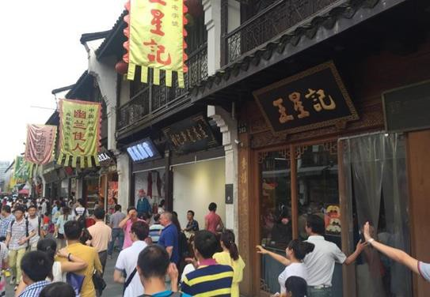

APPLICANT RESPONSIBILITIES

Applicant/Coordinating Organization
- Up to 24 high-caliber American students to participate in our program. All students must be first time participants.
- Selection process: interviews should to be conducted to ensure the quality of students, and most importantly to make sure the candidate has expressed strong interest in Chinese culture and history. All participants must be full-time students currently enrolled in a college or university.

- Selected student must participate in mandatory
- College will provide funds to cover international travel-related costs for the group, including but not limited to:
  - Round-trip international airfare to China
  - Passport fees (if applicable)
  - China visa fee
  - Travel insurance
Each student is expected to contribute $250.00 for the cost of the experience. Each student will also participate in an independent study experience and have the opportunity to earn up to 2 credits.
- Selected students must participate in mandatory pre-trip briefings for students and chaperones to introduce participants to CUSEF’s program and for students to learn about the goal of the trip.

APPLICATION

Instructions and Processes for Participation
- Please complete the following application form in its entirety to indicate interest in participating
- Return completed application form to: Dr. Siri Brown, Merritt College Building D room 217
- Deadline to submit completed application form: February 20, 2017

