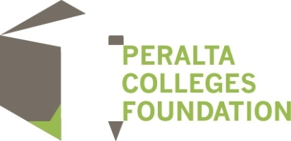

Scholarships for 1st year students are being offered for the Spring Semester of 2017

Applications open January 17, 2017

The 5021 Scholarship
Ivan J. Houston Scholarship

Application deadline:
February 28, 2017 @ mid-night

To apply go to www.peraltafoundation.org and click on:

