The
Merritt Connection

February 8, 2017 Dr. Marie-Elaine Burns, Interim President

After Spending Years Reaching Her Goals, Doris Hankins Helps Others Find Theirs
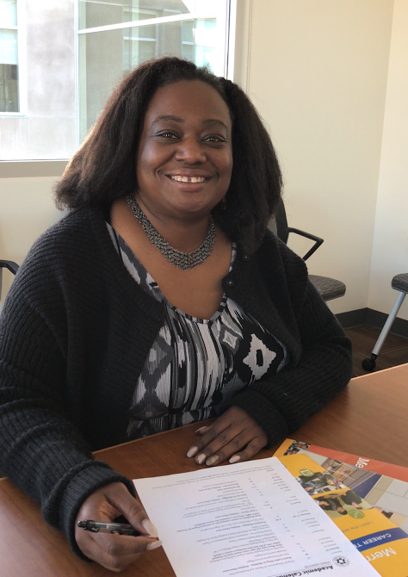
It’s easy for Doris Hankins to remember when she was earning her associate’s, bachelor’s, and master’s degrees: she was pregnant during each one.

It was a struggle, but she persevered and succeeded because getting an education was so important to her. She attended multiple community colleges, held a variety of jobs in numerous fields, and raised a family along the way.

She knew she had found her calling when selected to be the Employment Services Manager for Merritt’s new Career Institute and Job Center as it would allow her to help current and/or re-entry students and displaced workers by finding externships and internships for them that could lead to potential employment. Her goal is to begin working with industry partners to create Work-Based Learning opportunities at the college, set up informational interviews and job-shadowing, discover new opportunities to connect students and community members, and build out various advisory committees to support our industry partners.

“In my new role, I’ll be meeting with students and community members from all walks of life to find out how I can help fulfill their employment needs. I will be matching up students with our industry partners who can provide opportunities for experience in the field, and I’ll be recommending career and skill-building workshops to help in the process,” says Doris. “I went through all those same questions of what to do with my life, and I hope to share my experiences and be an inspiration.”

Doris took a circuitous path to get to Merritt, but when she got there, she never left. A resident of Vallejo, she committed to finishing school, and found the most support at Merritt where she would eventually earn two associate degrees before continuing her education at various online universities that made it possible for her to study at home.

Merritt was also where she would find a long-term career. She applied for an hourly classified job in Merritt’s Career Center (previously located in the Q Building) and was first hired to work as a Senior Clerical Assistant in the office of former President Dr. Evelyn Wesley. In that office, Doris was allowed to adjust her schedule to meet her educational goals, a kindness she never forgot. She then went on to become the permanent Senior Clerical Assistant to the President. Five years later, she was hired as the Staff Assistant in the Office of the Vice President of Instruction up until now. During that time, she was inspired to become more involved in leadership roles and developed an understanding of the college processes after going through the Chancellor’s Leadership Program.

“While I was working and simultaneously getting my master’s in business and communication, I started joining different committees because I wanted to support the students rather than just sitting on the sidelines,” says Doris. “I wanted to speak up for those who couldn’t and be part of the institution’s success. I never wanted to forget where I came from and to always remember what it’s like to be on the other side of the counter.”

Today, Doris is pleased with her accomplishments and what she has been through. She wishes to make her whole family proud but most importantly her parents. Her father came close to finishing college but stopped to raise his own family. Her mother taught her the value of hard work and to never give up, regardless of the obstacles.
“I was completing my last semester and thinking ‘thank god, I don’t have to do this while I’m pregnant.” I had a plan but then thought, ‘how is this going to work out?’” Doris was lucky to have a supportive husband, Welique, and children (Laci, 16 and Malique, 14) behind her (now joined by Lyric, 2-1/2), and, as always, has made it work.

“I wouldn’t trade my family for anything,” says Doris. “But I’m happy to be in a place where I can also help others. I truly believe in Merritt’s slogan, ’We Change Lives.’ So I’m looking forward to helping students reach their goals by nurturing their progress just like a flower—giving them enough water and the right light and watching them blossom. It’s a beautiful thing.”

