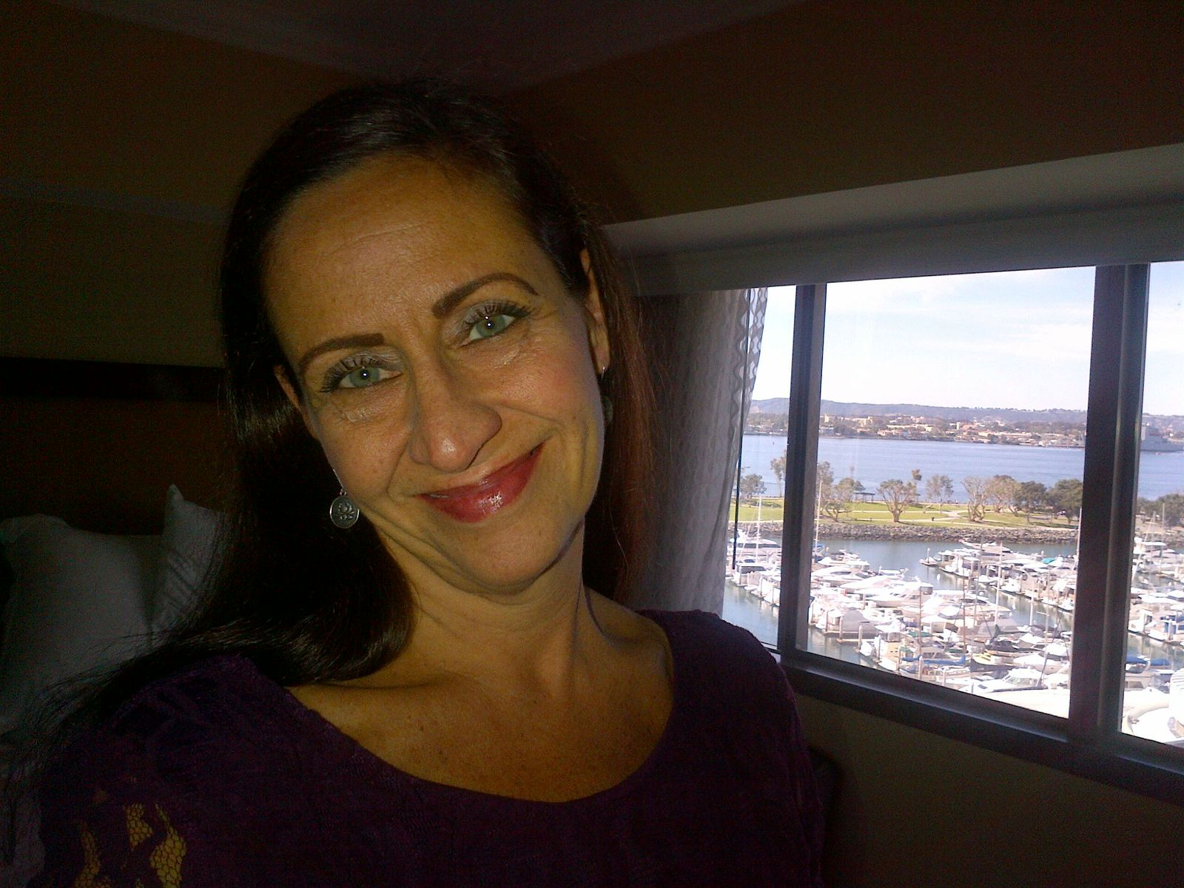L
Lisa M. Lasky, Senior Director
Lisa has worked in education for over 25 years as a teacher, leader, school and district coach, and has led several organizational/system change projects across the country. Before joining the National Equity Project in 1995, Lisa worked with Theodore Sizer at the national office of the Coalition of Essential Schools – a national school reform movement that began with five high schools and expanded to 1000’s of schools and several centers across the country. She moved to the Bay Area from the East Coast to grow a local center (BayCES). As a founding member of our organization, she has served in many roles including Associate Director, Director of Elementary and Middle Schools, Director of the School Grants Program and Deputy Director. She currently leads our Leadership Development and Coaching Division – overseeing support and services to a portfolio of clients from California to Mississippi.

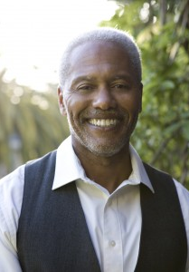

Victor Cary, Senior Director
Victor has worked in education for over 40 years, starting as a high school teacher in Richmond, CA. As Senior Director at the National Equity Project, he leads the development of our equity-centered coaching and leadership model, and currently facilitates Leading in C.A.O.S. (Complex, Adaptive, Oppressive Systems) with educators and communities across the country, particularly collective action initiative.
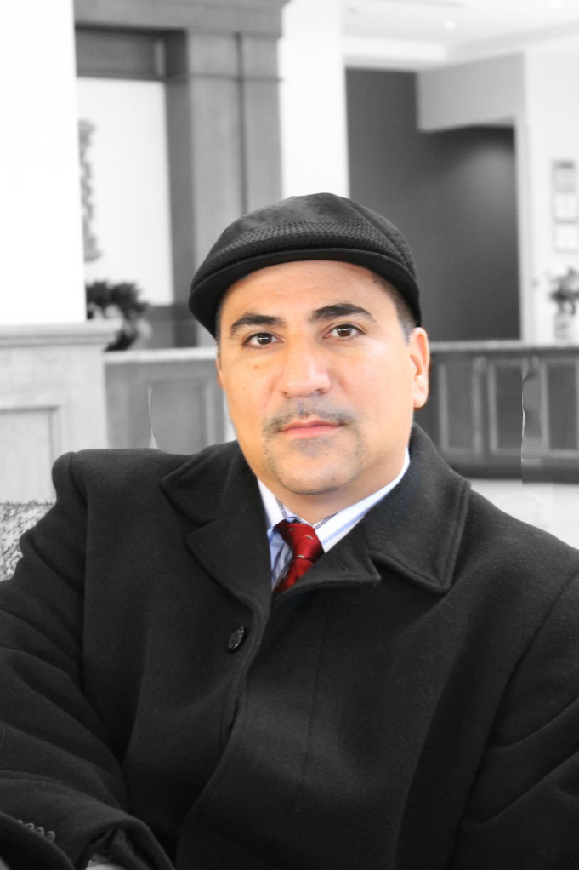

Dr. JuanCarlos Arauz, E3: Education, Excellence & Equity
Biography
Dr. JuanCarlos Arauz is one of the most sought after educational experts as he inspires and captivates his audiences. He has mastered the art of addressing the delicate topics of 21st century education, immigration, and Black/Brown male youth development. He translates these issues so that they are relevant to participants by providing a rare expertise through his lived experience as an immigrant of color and learned experience through earning a doctorate in International & Multicultural Education. Consequently, his creative and unique approach provides audiences with the insight of the challenges as well as innovative tools for students and teachers in the classroom. He has been featured in a documentary that focuses on contemporary civil rights activists and has traveled around the country as an inspirational ‘Spoken Word’ storyteller. His fresh and compelling vision brings collaboration between the private and public sectors, providing solutions to humanize the educational process for every student and educator. He believes we cannot have educational excellence without equity. (www.youtube.com/user/e3education)
Dr. Arauz received his BA in Education and MA in Social Science Education from the University of South Florida. He received his Ed.D. in International and Multicultural Education at the University of San Francisco. His dissertation research focused on the racial identity development of undocumented Latin@ youth. He currently is the Executive Director of E3: Education Excellence & Equity and an adjunct professor at Dominican University. In addition, he has served as a trustee for several independent schools and educational organizations.
JuanCarlos is a proud member of a family that includes his spouse, a woman of grace, and eight children (there’s a story!). He and his partner have extended their family to include 21 wonderful foster youth. He is bilingual in Spanish and English, was born in Brazil to Nicaraguan parents and immigrated to the United States, lived in several countries, taught in the classroom and coached female and male high school state basketball championship teams, all of which have provided him with unique insight to issues that educators face today.

Willing to be Disturbed | By Margaret J. Wheatley
As we work together to restore hope to the future, we need to include a new and strange ally— our willingness to be disturbed. Our willingness to have our beliefs and ideas challenged by what others think. No one person or perspective can give us the answers we need to the problems of today. Paradoxically, we can only find those answers by admitting we don’t know. We have to be willing to let go of our certainty and expect ourselves to be confused for a time.
We weren’t trained to admit we don’t know. Most of us were taught to sound certain and confident, to state our opinion as if it were true. We haven’t been rewarded for being confused, or for asking more questions rather than giving quick answers. We’ve also spent many years listening to others mainly to determine whether we agree with them or not. We don’t have time or interest to sit and listen to those who think differently than we do.
But the world now is quite perplexing. We no longer live in those sweet, slow days when life felt predictable, when we actually knew what to do next. We live in a complex world, we often don’t know what’s going on, and we won’t be able to understand its complexity unless we spend more time in not knowing.
It is very difficult to give up our certainties—our positions, our beliefs, our explanations. These help define us; they lie at the heart of our personal identity. Yet I believe we will succeed in changing this world only if we can think and work together in new ways. Curiosity is what we need. We don’t have to let go of what we believe, but we do need to be curious about what someone else believes. We do need to acknowledge that their way of interpreting the world might be essential to our survival.
We live in a dense and tangled global system. Because we live in different parts of this complexity, and because no two people are physically identical, we each experience life differently. It’s impossible for any two people to ever see things exactly the same. You can test this out for yourself. Take any event that you’ve shared with others (a speech, a movie, a current event, a major problem) and ask your colleagues and friends to describe their interpretation of that event. I think you’ll be amazed at how many different explanations you’ll hear. Once you get a sense of the diversity, try asking even more colleagues. You’ll end up with a rich tapestry of interpretations that are much more interesting than any single one.
To be curious about how someone else interprets things, we have to be willing to admit that we’re not capable of figuring things out alone. If our solutions don’t work as well as we want them to, if our explanations of why something happened don’t feel sufficient, it’s time to begin asking others about what they see and think. When so many interpretations are available, I can’t understand why we would be satisfied with superficial conversations where we pretend to agree with one another.
There are many ways to sit and listen for the differences. Lately, I’ve been listening for what surprises me. What did I just hear that startled me? This isn’t easy—I’m accustomed to sitting there nodding my head to those saying things I agree with. But when I notice what surprised me, I’m able to see my own views more clearly, including my beliefs and assumptions.
Noticing what surprises and disturbs me has been a very useful way to see invisible beliefs. If what you say surprises me, I must have been assuming something else was true. If what you say disturbs me, I must believe something contrary to you. My shock at your position exposes my own position. When I hear myself saying, “How could anyone believe something like that?” a light comes on for me to see my own beliefs. These moments are great gifts. If I can see my beliefs and assumptions, I can decide whether I still value them.
I hope you’ll begin a conversation, listening for what’s new. Listen as best you can for what’s different, for what surprises you. See if this practice helps you learn something new. Notice whether you develop a better relationship with the person you’re talking with. If you try this with several people, you might find yourself laughing in delight as you realize how many unique ways there are to be human.
We have the opportunity many times a day, everyday, to be the one who listens to others, curious rather than certain. But the greatest benefit of all is that listening moves us closer. When we listen with less judgment, we always develop better relationship with each other. It’s not differences that divide us. It’s our judgments about each other that do. Curiosity and good listening brings us back together.
Sometimes we hesitate to listen for differences because we don’t want to change. We’re comfortable with our lives, and if we listened to anyone who raised questions, we’d have to get engaged in changing things. If we don’t listen, things can stay as they are and we won’t have to expend any energy. But most of us do see things in our life or in the world that we would like to be different. If that’s true, we have to listen more, not less. And we have to be willing to move into the very uncomfortable place of uncertainty.
We can’t be creative if we refuse to be confused. Change always starts with confusion: cherished interpretations must dissolve to make way for the new. Of course it’s scary to give up what we know, but the abyss is where newness lives. Great ideas and inventions miraculously appear in the space of not knowing. If we can move through the fear and enter the abyss, we are rewarded greatly. We rediscover we’re creative.
As the world grows more strange and puzzling and difficult, I don’t believe most of us want to keep struggling through it alone. I can’t know what do from my own narrow perspective. I know I need a better understanding of what’s going on. I want to sit down with you and talk about all the frightening and hopeful things I observe, and listen to what frightens you and gives you hope. I need new ideas and solutions for the problems I care about. I know I need to talk to you to discover those. I need to learn to value your perspective, and I want you to value mine. I expect to be disturbed by what I hear from you. I know we don’t have to agree with each other in order to think well together. There is no need for us to be joined at the head. We are joined by our human hearts.
From Turning to One Another: Simple Conversations to Restore Hope for the Future 2

