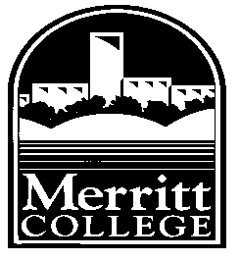
PROFESSIONAL DEVELOPMENT COMMITTEE

Professional Development Workshop Proposal (FLEX DAY) Form

August 14 – 15, 2016 Flex Day Program Theme

Strengthening Our College Together:
Time for Action!

Complete the Proposal Form and send as attachment to jholloway@peralta.edu by April 24,2016.
Telephone:
Facilitator (contact person):

Email:

Projected date(s) of Activity: (August 14, 2016 or August 15, 2016)

Title (theme) of Activity:

Proposed

Date: Time: Duration: College/Rm:

Suggested Class Size

Minimum: Maximum:

Expected Outcomes:

Description of Activity:
Please attach supportive information—brochures, flyers, etc.

Personnel Involved (PCCD/Campus Staff, Consultants):

Name Title Telephone

__________________________ _____________________ ______________

__________________________ _____________________ ______________

__________________________ _____________________ ______________

__________________________ _____________________ ______________

Audio/Visual and other IT needs (Internet connectivity, computer projection, etc):

_________________________________________________________________

_________________________________________________________________

_________________________________________________________________

Date Received by the Merritt Professional Development Committee:

________________________________________________________________

Facilitator(s) notified by:

________________________________________________________________

Comments: ________________________________________________________________

________________________________________________________________

________________________________________________________________

________________________________________________________________

________________________________________________________________

